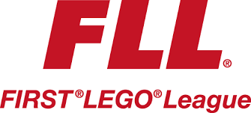
The FIRST® LEGO® League Core Values are the cornerstones of the FLL® program. By embracing the Core Values, participants learn that friendly competition and mutual gain are not separate goals, and that helping one another is the foundation of teamwork. Learn more about the Core Values in Chapter 4.
FIRST® LEGO® League Core Values:
▲ We are a team.
▲ We do the work to find solutions with guidance from our Coaches and Mentors.
▲ We know our Coaches and Mentors don’t have all the answers; we learn together.
▲ We honor the spirit of friendly competition.
▲ What we discover is more important than what we win.
▲ We share our experiences with others.
▲ We display Gracious Professionalism® and Coopertition® in everything we do.
▲ We have FUN!
