Rector Cougars Team 1950
Team Highlights
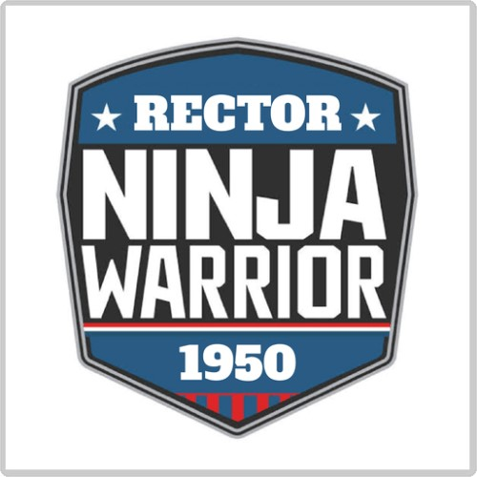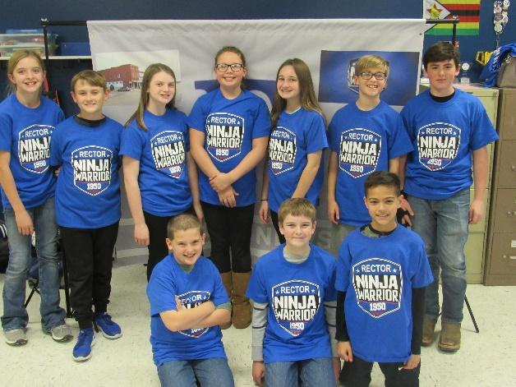

Robot Missions
- Have 9 missions successfully programmed
- All of them are on video to show successful runs
- Average points in 2:30 is 130 w/o bonus, 200 w/bonus
- Highest points we can get is 225 w/o bonus, 330 w/bonus

Core Values
- Used Coopertition and Gracious Professionalism during a chess competition
- Everyone has a role for each aspect: robot, project, core values
- Have 3 main team goals for our team
- Love to have FUN as a team

Project
- Multiple resources- American Ninja Warrior contestants (Dr. Noah Kaufman and Ian Dory), Dr. Judy Leach, our mayor, lawyers, books (People Habitat- 25 Ways to Think About Greener, Healthier Cities), websites (Center for Disease Control, World Health Organization, Kaboom), journals (American Journal of Medicine)
- Shared with mayor, teachers, classmates, another school, American Ninja Warrior contestants, school board
- Helping to bring new life to our downtown area by using an abandoned space to provide a place to install a ninja playground that will help promote living a healthier lifestyle.

